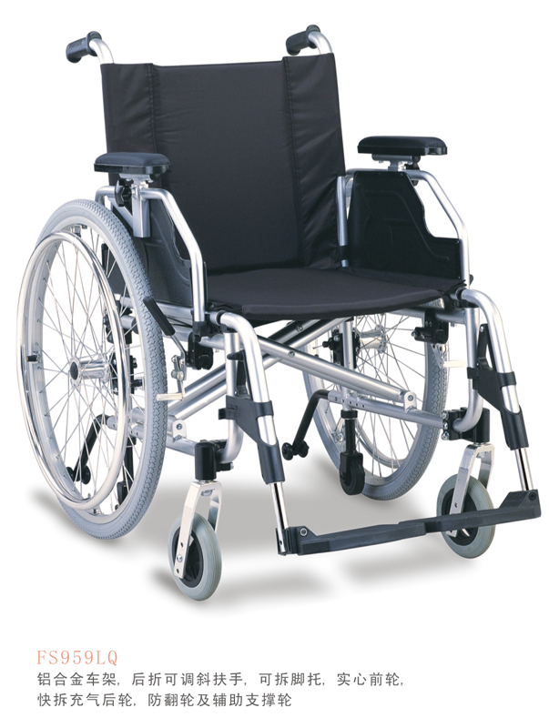

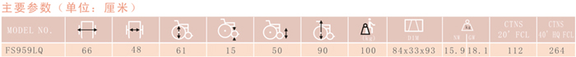

Specifications:

1. Aluminum Chair Frame
2. Flip-up and Height-Adjustable inclined armrest
3. Detachable Footrest
4. Solid Castor
5. Quick release pneumatic rear wheel
6. Carrying wheel and anti-tippers