**HEBEI PUKANG MEDICAL INSTRUMENTS CO., LTD**

**20 years' experience in hospital furniture**

**CE- and FDA-approved | ISO 9001- and ISO 13485-certified | Exporting to 98 countries**

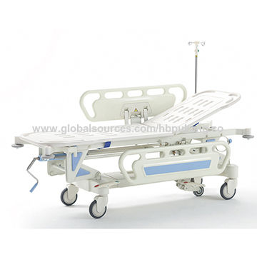

**E-3-#0128 Wheeled Stretcher**

**Key Specifications/Special Features:**

**Standard features**  
•  Advanced electrostatic plastic spray of surface, anti-aging and anti-rust.  
•  Bed frame is profile steel, stable and reliable  
•  Both of the platform and side rails are ABS materials  
•  Backrest is controlled by hydraulic auxiliary spring  
•  Height adjustable by crank  
•  Equipped with steering castor  
•  4-wheel, Ø125 mm, 360° swivel wheels  
•  Central locking with brake pedal

**Specifications**  
Model number: E-3 hospital stretcher  
Overall length: 77.0" (196.0cm)   
Overall width: 26.0" (66.0cm)  
Weight capacity: 330.7lbs (150kg)   
Height range (to litter top)  
High: 34.0" (87.0cm)  
Low: 23.0" (58.0cm)   
Patient surface: 24.0" x 61.0" (90 x 193cm)  
Caster diameter: 4.9" (12.5cm)  
Temperature of work environment: 5-40°C  
Hospital grade plug: yes