**ALS-ST004**

Size:1930*640*500/900mm

Material:

It is made of electrostatic spray and aluminum alloy frame, top is high quality foam

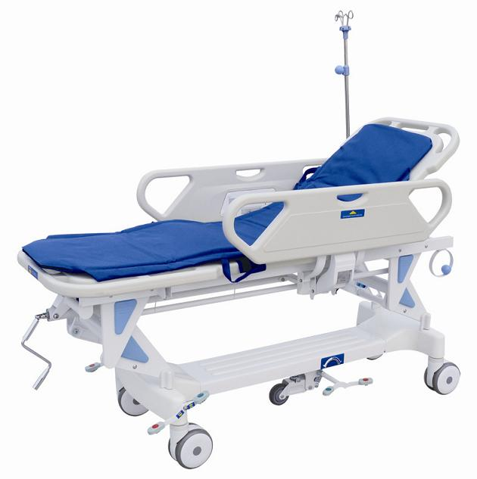 in the mattress, cover is high quality artificial leather .

* Two ABS guardrails on both sides of stretcher.

* Back section is adjusted by gas spring: 0-75 degree.

* Height is adjustable: 400mm

* Adjustable directional caster, mattress.

* 6" central controlled caster.

* Product size is made according to customer's demand.

Parameters:

* Load bearing: 135kg

Standard Accessories：

1. infusion stand Oxygen bottle holder