ALS-ST004

Size:1930*640*500/900mm
Material:
It is made of electrostatic spray and aluminum alloy frame, top is high quality foam
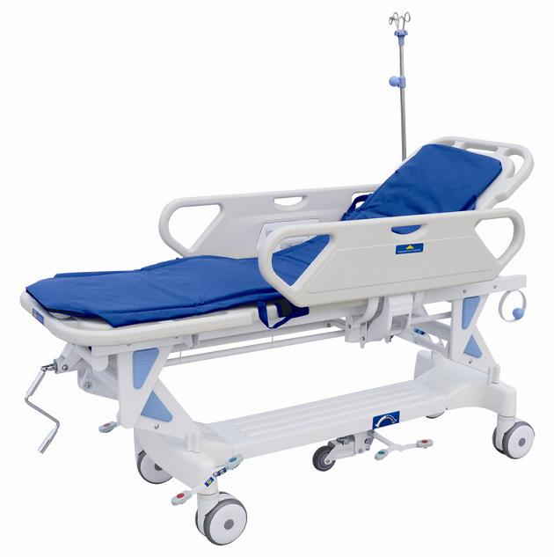
in the mattress, cover is high quality artificial leather .
* Two ABS guardrails on both sides of stretcher.
* Back section is adjusted by gas spring: 0-75 degree.
* Height is adjustable: 400mm
* Adjustable directional caster, mattress.
* 6" central controlled caster.
* Product size is made according to customer's demand.

Parameters:
* Load bearing: 135kg

Standard Accessories：
- infusion stand Oxygen bottle holder

