**LUXURIOUS STRETCHER**

**E-3 OPERATING MANUAL**

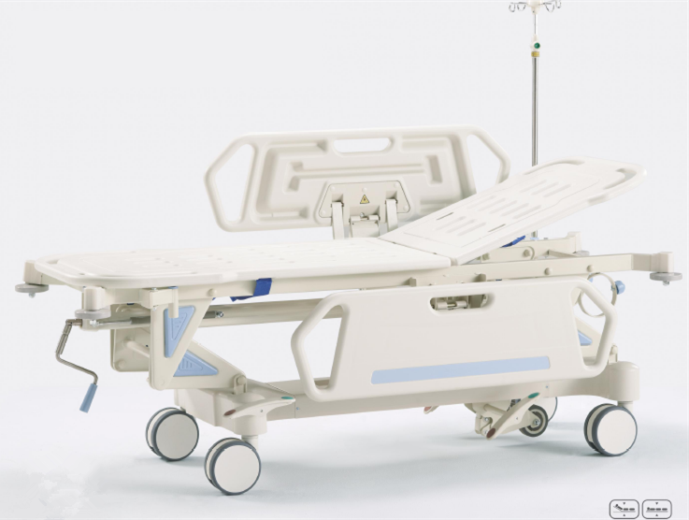

Please read the instructions carefully before use

HEBEI PUKANG MEDICAL INSTRUMENTS CO., LTD

Introduction:

E-3 medical vehicles which have been produced for many years, through market research, customer feedback and clinical data in the production process, have gradually improved. The materials, processes, equipment and human capacity, in accordance with international standards are strictly controlled. The product structure, function and performance all reached the international requirements. It has advantages of beautiful appearance, economical and practical, simple operation, safety and reliability.

A: name, specification and model.

Name: emergency/recovery trolley (hydraulic)

Specification: 1960×660×580/870

Model: E-3

B: intended use and scope

This product is expected to be used in various medical institutions for treatment delivery, rescue and diagnosis. It has functions such as back fold, leg bent, move and brake. This product is applicable to adults who is 1646 ~ 1761 mm in height, weighing 70 ~ 78 kg. It does not apply to patients with mental retardation and hyperactivity, children and patients with severe burns.

C: specification and model.

1960 mm: the length in whole

660 mm: the width

580 mm: the minimum distance between the platform and the ground.

870 mm: the maximum distance between the platform and the ground.

CN: nurse care for short.

05: design series number

E-3: product classify number

D: designated authorized representative with the European Member States (EEA) (figure 1)

|  |  |  |  |  |
| --- | --- | --- | --- | --- |
| Member state | agency | Link man | telephone | Fax |
|  |  |  |  |  |
|  |  |  |  |  |
|  |  |  |  |  |
|  |  |  |  |  |
|  |  |  |  |  |
|  |  |  |  |  |
|  |  |  |  |  |

E: environmental condition and requirement of convey

a) storage conditions

1, temperature: -5 ° ~ 40 °

2, relative humidity: ≤ 85%

3, atmospheric pressure: 86kpa ~ 106kpa b) operation environmental conditions.

1, temperature: -5 ° ~ 40 °

2, relative humidity: ≤ 85%

3, atmospheric pressure: 86kpa ~ 106kpa c) the requirement of the convey.

1, not inverted

2, 100x114_c00b7b7aa handle with care



3 moisture

4、impact banned

5、When loading and unloading with forklifts, fork distance of should be1m, in vertical cross into the middle part.

F: Structure character and working principle

a) Structure character

The support components of the trolley is made of steel, the main material of it is standard cold-formed shaped steel tubing, comply GB/T6728 standard, using advanced welding process. The material of parallel is ALSi12, lined steel skeleton. Side rail is composite structure and its main material is AI and ABS engineering plastics

b) Working principle

The function of movement is achieved by the four castors while the function of brake is achieved by chain-driven cam lever pedal pressure setup. The under frame is equipped with directional control setup, which making the product easy to operate when it moves. The fold of the backboard adopt two controllable industrial gas springs. It is manual control and can be locked at any angle. The lifting in level adopts Screw thrust device drivers support the chain geometry and is also manual control.

G: Check out of box

After receiving the delivery of products, customers should first check out of the box, verify that the product is consistent with the purchase requests, and then check accompanying documents and attachments whether are complete or whether there are any damage caused by the transport. If everything is out of question, to install by the following procedure, or should contact the dealer to replace consultation matters.

H: Installation

a) Brake system: (figure 1)

1. Brake shaft 2. M5 bolt 3.Brake pedal 4.underframe 5. Brake arm 6.link rod 7. Washer 8.forelock 9. Pin axis 10.castor fixed cover 11.castor 12. Brake shaft 13. Bolt 14.washer

1 2 3 4 5 6 7 8 9 10 11

13 14

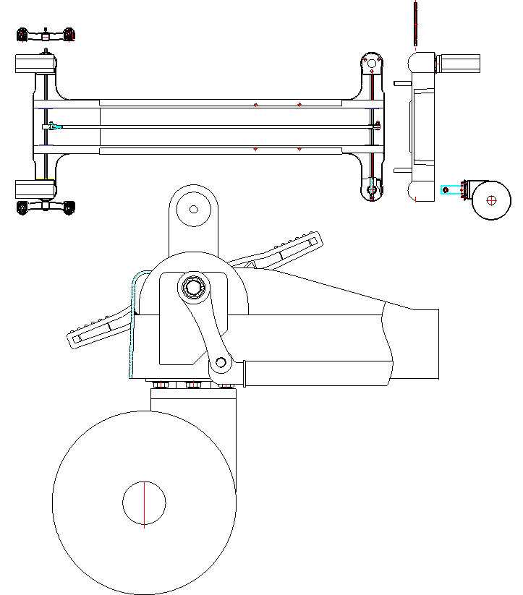 12

Angle of brake arm

Ear seat

Castor installation

Screw it during castors installation

Take under frame ( figure 1,4), put the ear seat on the ground, and then take another four castors (figure 1,11), install them according to the sighed location,( the axis with hexagonal hole at the inserting end should be parallel with the direction of the brake shaft. The brake direction of the four castors must be all the same, that is to say, revolve in the direction of arrowhead is to brake and revolve in the reverse direction is to release), fasten the bolt.

Take brake shaft 2(figure 1,12), (The internal thread at both ends of this axis is for the M8.) insert it into the side-by-hole of the under frame.( the four castors should be in the state of brake. Add the brake arm in the angle of 22.5 degrees with the ground when the brake shaft is inserted to the middle, and then continue to insert it to the required location, locking the brake shaft with bolt(figure 1,13) and washer(figure 1,14), move the brake arm to the middle and put split washer to the rabbet of both ends of it.

Then take brake shaft1 (figure 1,1), install it in the method mentioned above. At last take two brake pedals (figure 1,3), install it from the both ends of the brake shaft(the end of the pedal with red sign is out), locking it with bolt of M5. Take brake link rod(figure 1,6), and install two brake arm separately at the both ends of the link rod. Insert it with pin axis (figure 1,9), at last lock it with washer (figure1,7) and forelock(figure 1,8).

b) Installation of directional castor: (figure 2)

1 2 3

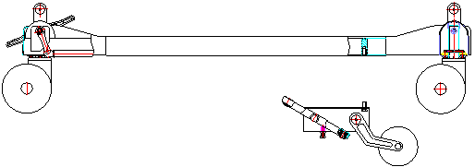

Take directional castor groupware (figure 2,1), make the four assemble holes be right with the

threaded hole(figure 2,3) ( place it according to the signed direction), tightening it with bolt(figure 2,2) and spring pod.

c) Lifting system and installation of platform(figure 3)

1 Screw rod assemble hole 2 Screw rod support 3 Platform support 4 Bolt 5 Geometric support assemble hole 6 Geometric support 7 Platform assemble hole 8 M10 nut 9 Screw rod mandrill assemble hole 10 Chain lifting support 11 Forelock 12 Gas spring 13 Gas spring support 14 Pin axis 15 Back controller base 16 Geometric support link hole 17 Geometric support link shaft 18

Geometric support base 19 Under frame base 20 Booster gas spring assemble hole 21 Chain lifting support assemble hole 22 M1nut 23 Tailor-made bolt 24 Trolley up frame 25 Lifting screw rod 26 Trolley platform

1 2 3 4 5 6 7 8 9 10 11 12 13 14 15

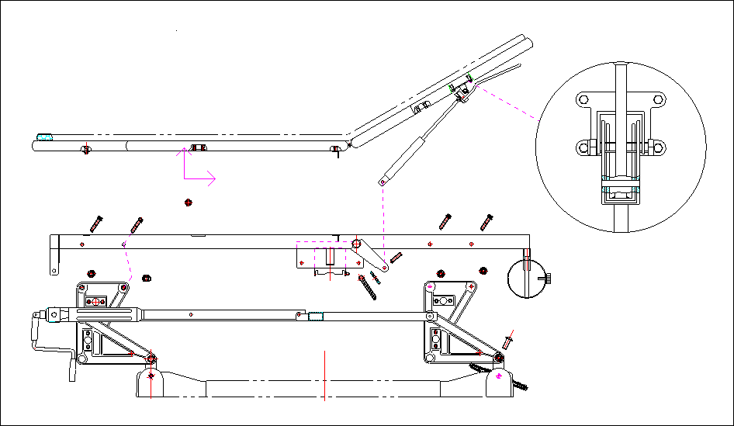

16 17 18 19 20 25 26 21 22 23 24

Put the under frame downwards with four castors on the ground make it be in the state of brake.

Take geometric support B (figure3, 18)(two each side), each left part and right is enantiomorphousely laid as a group. Take geometric support short link shaft (figure 3,17), insert it into M10 bolt from outside according to the signed location. Lock it with spring pad and nut from the inside. Superpose the two groupware and the under frame base. Nylon gaskets are added to the clearness. Insert the tailor-made bolt from the outside and screw it with nuts and washers.

2. Take four geometric supports A(figure 3,6), install it with long link shaft in the same way and coincide with geometric support B, insert the tailor-made bolt to link it from the outside of the geometric support link hole(figure 3,16)

3, take chain lifting support(figure 3,10), screw it with bolt from the assemble hole(figure 3,21), making the front and back group linked so as to achieve the purpose of move.

4, take trolley up support(figure 3, 24), making assemble hole(figure 3, 5) be right with the holes of the geometric support A, inserting bolt(figure3,4) from outside and locking it inside with spring pad and bolt(figure 3,8)。

5，Take lifting screw rod(figure 3, 25), firstly, make the assemble hole(figure 3,1) be right with the assemble holes of the screw rod and link it with bolt. Then coincide superpose the screw rod mandrill assemble hole (figure 3,9) and U wrench control of chain lifting support and lock it with 10×45 pin axis, washer and forelock. There is boost gas spring assemble clip at the both sides of the screw rod support and there is there is assemble hole at the screw rod mandrill (figure 3,20), put two boost gas spring and link it there with pin axis and bolt.

6. Take trolley platform (figure 3,26), put it flatwise on the top carriage. There is threaded hole on the rear of it. Platform support belt with installed hole is welded on the trolley. Make the holes be right and tighten it with bolt.

7. Installation of back control gas spring

Put the back control base (figure 3,15) on the pit under the platform. Lock it with bolt at the installed hole, and then make the assemble hole at the lower end of the gas spring (figure 3,12) be right with the assemble hole of the top carriage gas spring(figure 3,13). Link and lock it with pin axis, washer and forelock.

d) Installation of side rail (figure 4)

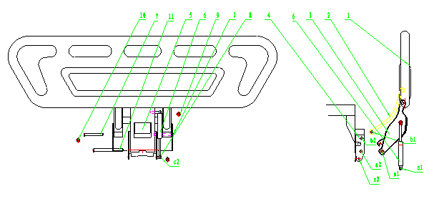

1 main body of the side rail 2 arched support 3 main controlling board 4 installed bottom board 5 controlling wrench 6 damper 7 short pin with two grooves 8 damper pin 9 circlips for shaftφ8 10 circlips for shaftφ10 11 long pin with two grooves

Installed bottom board (figure 4,4) is welded at the both sides of the trolley top carriage. Take two main bodies of the side rail. Anastomose main controlling board and the installed bottom board. Make the assemble hole a1 be right with the hole a2. Insert the pin with two grooves(figure 4,11) into the hole and lock it with circlips for shaft(figure 4.10). Then superpose the assemble holes b1 and b2 of the arched support(figure 4,2), insert the short pin with two grooves(figure 4,7) and lock it with circlips for shaft.

Link the assemble hole c1 at the lower end of the damper (figure 4,6) and pin of the damper. At last lock it with circlips for shaft.

I: Preparation before use

Every function of the product should be confirmed before it is put into use. The method is that: no-load operation is carried out according to the instructions. At the same time, check whether there is any wrong with the moving parts and whether the index is in accord with the requirements.

J: Technique parameters.

a) Safe working load: 1700N

b) Board lifting range: >290 mm

c) Back board fold angle: ≥ 35°

d) load of the drip stand: ≤2Kg

e) noise: ＜65dB（A）

K: introduction of each unit of the trolley body



1

7

8

3

5

4

2

6

|  |  |  |  |
| --- | --- | --- | --- |
| number | Unit name | number | Unit name |
| 1 | Lifting handle | 5 | Oxygen cylinder locking knob |
| 2 | Brake pedal | 6 | Railing |
| 3 | Railing wrench | 7 | Gas spring wrench |
| 4 | Directional pedal | 8 | Back board |
|  |  |  |  |

L: Operation instruction

a) Movement of the trolley body

This product moves in virtue of manpower. Lift the brake system before it move. There are brake pedals at the both ends of the body below. The user can step the pedal (13) to lift braking according to the direction hinted. Step down the directional treadle to the limit place according to the cue, the trolley will move forward.

b) Oxygen therapy

Put the special oxygen battle into the kickstand and fasten the knob (1) to fix it when the patient needs oxygen therapy.

c) Operation of lift, fall and lean

Step the pedal (6) to and fro, the platform will lift vertically; the front and after lean of the platform can be achieved by stepping down the depression pedal according to the cue; step down (8) at the same time, the platform will fall vertically.

d) Fold the back board

Move the handle forward, the back board will fold up to the require angle when release it; move the handle downward with pressure, the back board will return to the original place.

e) Operation of the side rail

The collocation of the side rail is rotary.

Rotary side rail has two states of sagging and upright locking. The user hold the upside of it with one hand, wrench the controller (7) downward with another, the side rail will be in the state of sagging; while hold the upside of the side rail and move it upward with some force, the side rail will return to the upright locking state.

M: maintenance, protection and disinfection.

a) Maintenance: In the using process, the trolley should always be kept clean. Violent collision and overload operation is prohibited. The operator should control the intensity in the operation of pedals and handle. The product is against the sharp scratch of the surface; especially the hydraulic cylinder jacket should be to be protected from dust to affect life.

b) Protection: The protection is advised to be carried every six months. The method is that: remove each rotation and attrition part and wipe it with lubricated. Check and fasten each bolt, if there is any part wear and out, change it in time.

c) Disinfection: This product must be disinfected after each use, especially after the use of the patients with infection. Cotton soaked with both alcohol 75% and glutaraldehyde can be used to wipe it or other methods.

N: Abandon measure

The life-span of this product is 8 years. It should be out of use when its life-span comes to end. Different part should be disposed by different department according to the material.

O: Malfunction analysis and elimination

|  |  |  |
| --- | --- | --- |
| Description | Analysis | Elimination measure |
| Brake fail | Pin axis of the chain setup off | Renew it to be locked |
| Castor compaction setup frayed | Adjust the clearance of setup. |
| Castor damaged | Displace a new one |
| Fail to lift | hydraulic pressure control setup displaced | Adjust and correct |
| fluid cylinder conk out | Repair or displace a new one |
| Fail to lock the back board | Gas spring adjustable bolt start | Readjust and lock |
| There is something at the controller | Clear away the thing. |
| Gas spring damaged | Displace it |
| The side rail controller not work | Setup damaged | Repair or displace a new one. |

P: Notice

a) The trolley should be in the state of brake except when it needs to move.

b) The side rail of trolley must be upright locked when there is patient on it.

After the side rail upright locked, the user should shake it several times to make sure of the reliability of lock.

c) It is banned to move on a bumpiness road fast.

d) Force it to move in the state of brake.

e) Protection measure should be carried out when the trolley stride over channel or ridge of more than 50mm in case of suddenness happen.

f) The platform should be lowest without special requirement.

h) It is banned to stand on the platform in its state of fold in case of damage because of the convergence of the press.

i) The ozone space used to smoke should be without any flammable gas. The relative humidity should be kept below 80%

Q: Service promise

a) The warranty period of the product is 12 months from the date of purchase. Spare parts are offered in its whole life.

b) During the warranty period, contact the serve matter with the dealer. For the products sold in the Europe market, the pledge is responsible for by the authorized representative of EEA designated by our company.

R: Manufacturer information

Manufacturer: PRC HEBEI PUKANG MEDICAL INSTRUMENTS CO., LTD

Company address: DONGSHIDUAN TOWN XUSHUI COUNTY HEIBEI PROVINCE CHINA.

Telephone: +8/6-312-8592888 8592588

Fax: +86-312-8592026

Http：//www.hbpukang.com

E-mail：[pukang015@hbpukang.com](mailto:pukang015@hbpukang.com)