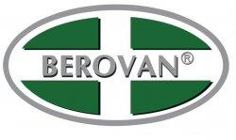

**BEROVAN MARKETING, INC.**

National Highway, Tabok, Mandaue City, Philippines 6014

Tel. No. 32-2303800 / 2303888

Fax. No. 32-2303862

------------------------------------------------------------------------------------------------------------

**AMBULANCE STRETCHER**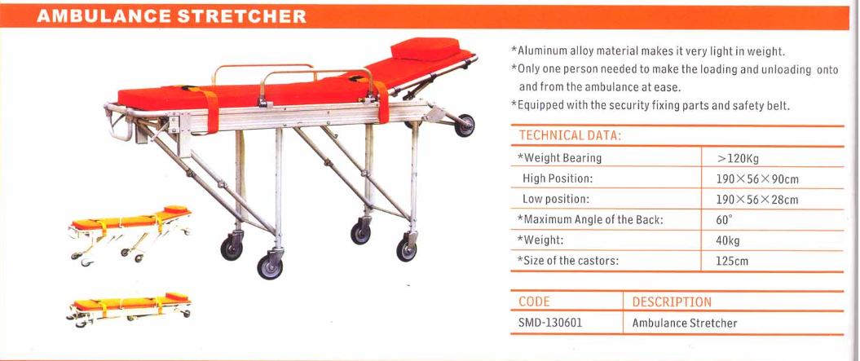

ARTICLE 170839