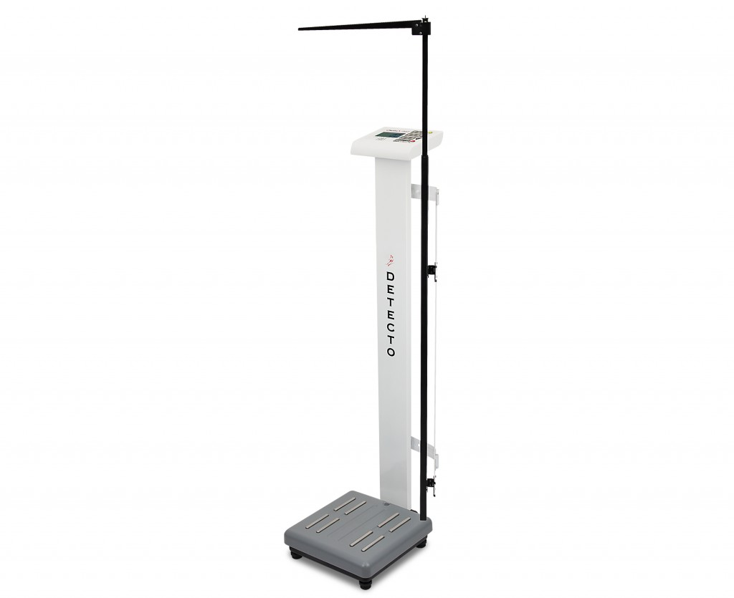

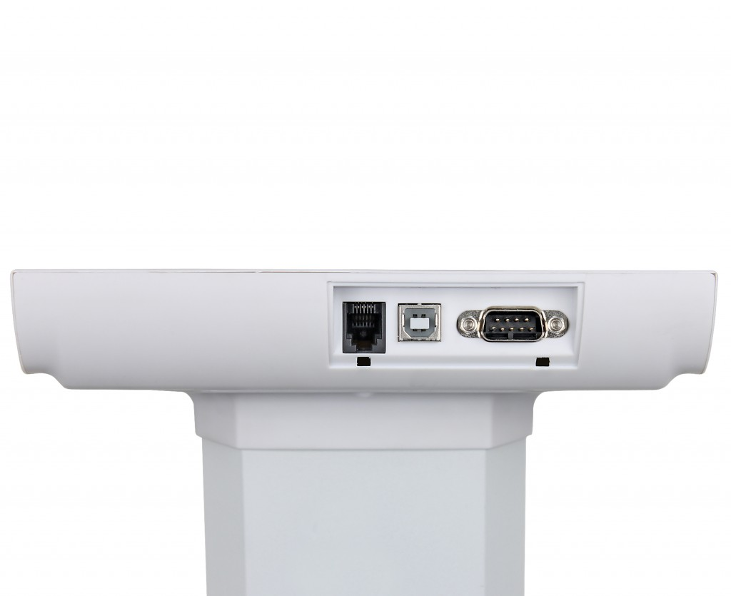

| **Specification** | **Description** |
| --- | --- |
| Capacity: | 0-220 lb x 0.1 lb (0-100 kg x 50 g) 220-550 lb x 0.2 lb (100-250 kg x 100 g) |
| Display: | 5 digit, 7 segment, 1.2 in / 29 mm high LCD |
| Power: | 6 AA batteries (not included) or 9V AC/DC adapter (not included) |
| Base Dimensions: | 12.5 D x 13 W x 3.33 H inch / 32 D x 33 W x 8 H cm |
| Overall Dimensions: | 48 x 12.6 x 17 in / 122 x 35 x 43 cm |
| Mechanical Height Rod: | 30 to 78 in / 76 to 200 cm |
| Shipping Weight: | 42.3 lb / 19.2 kg |
| Operating Temperature: | 50 to 104°F (10 to 40°C) |
| Keypad: | 10-key numeric, On/Off, Mode/Enter/Height, Lock/Release, Print/Units, 0/Zero, 1/Tare, Recall, Store |
| Body Fat Range: | 4% to 60% |
| Body Fat and Total Body Water Graduations: | 0.1% |
| Muscle Mass and Bone Mass Graduations: | 0.1% |
| Height Range: | 2' 5.5" to 7' 4.5" / 75 to 225 cm (manual input) |
| Age Range: | 10 to 85 years |

These professional doctor scales are designed to meet the medical-grade accuracy you depend on. They measure body fat, muscle mass, bone mass, and body water percentages. Detecto’s model PD350MHR features digital weight and mechanical height measurement. EMR/EHR-ready USB and serial ports. The ProDoc series heavy-duty scales can 0-220 lb x 0.1 lb (0-100 kg x 50 g) 220-550 lb x 0.2 lb (100-250 kg x 100 g). The LCD display provides easy-to-view 1 inch (25 mm) high readouts. Manual height rod measures 30 to 78 inch (76 to 200 cm). Optional P50 printer is available.