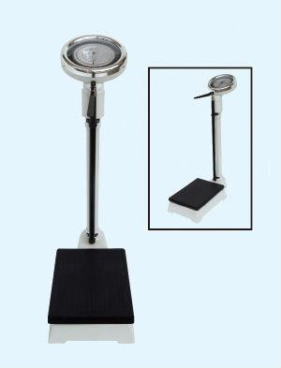

**Specifications**

Electronic weight scale   
competitive price and high quality   
delivery rapidly   
CE/ISO approved 

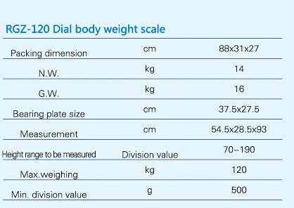

Model Number: RGZ-120   
Type: Medical / Personal Scale   
Adult scale / personal scale / health scale:

Max.capacity:120kg;

Scale with KG & LB two displaying; Alloy height measuring rod  
  
Adult Scale / personal scale / health scale:  
Max.capacity:120kg;  
Graduation:500g;  
Scale with KG & LB two displaying;  
Hight measure range: 70cm-190cm;  
Hight graduation:5mm;   
Load platform area: 37.5x27.5cm;  
Packing: 30X35X93cm;  
Net Weight: 19kg;  
Gross Weight: 20kg;