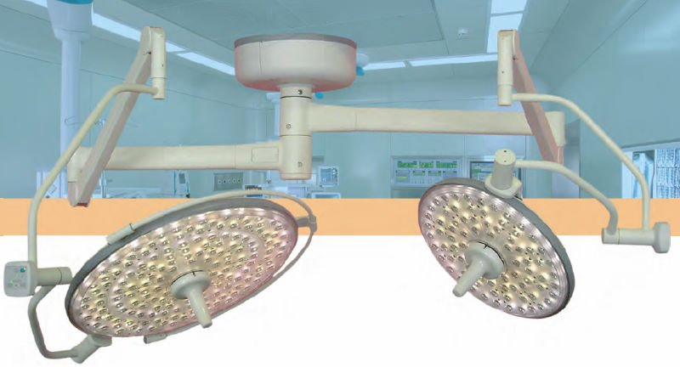

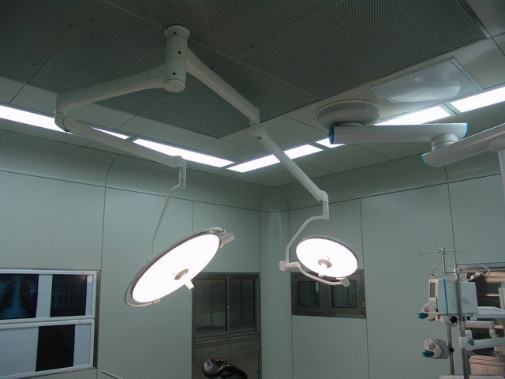

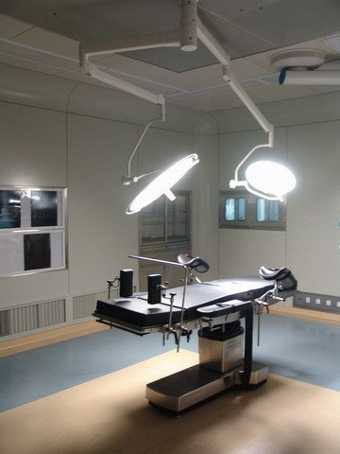

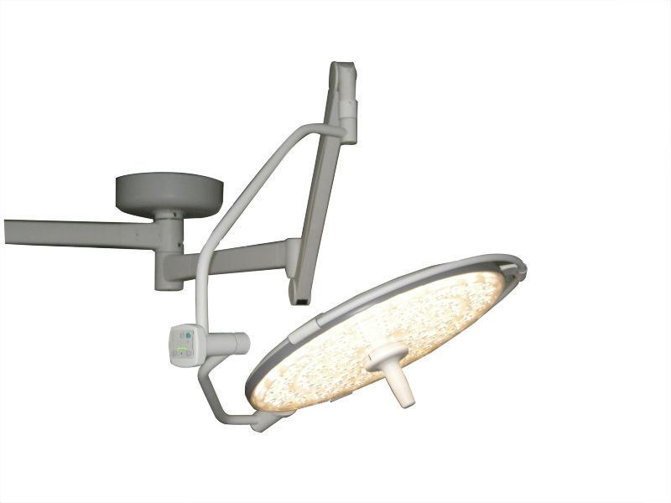

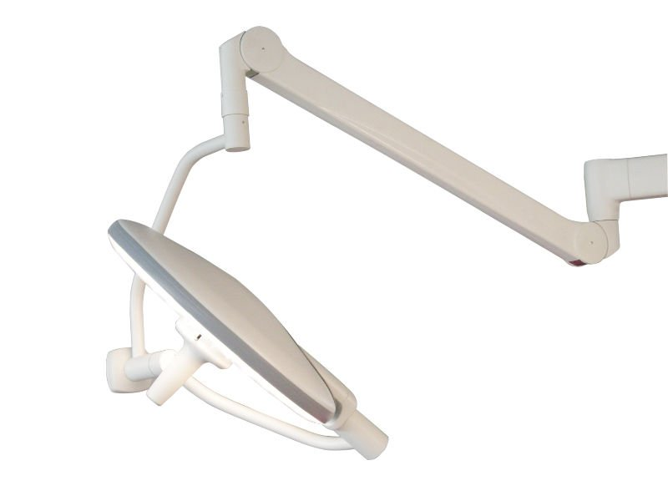

**Specifications**

LED aperating lamp 

**Purelit OL9570/50 High-end LED Shadowless Lamp**

Adopt the most advanced international LED as light source of shadowless lamp

Environmental protection, low power consumption and long life LED lamp with long service life of more than 20,000 hours

LED bulbs have no infrared and ultraviolet radiation

Flat light panel pressure injection molding, completely eradicating the influence on patients caused by the rupture of lamp surface.

**Background illumination lamp is included, flexibly supplying the**auxiliary light source for laparoscopic operation.

The streamlined ultra-thin design with less air resistance to facilitate the arrival of purified air to operation wound.

Overhead built-in power supply system, avoiding the complicated installation of wall-mounted control box.

Digital control by Micro-computer, with 10-grade brightness options and automatic memory.

Light suspension system of balance body, six groups of joint interaction, easy mobility, stable positioning, 360 ° all-round design, fully meeting the height and angle requirements for operation.

Purelit OL9570/50

OL9570/50LED System Composition Diagram for Operation Shadowless Lamp

OL9570/50 Technical Data for High-end LED Shadowless Lamp

|  |  |
| --- | --- |
| Model  Technical Specifications | OL9570/50 |
| Illumination (lx) | ≥120000/8000 |
| Color temp. (K) | 4300 |
| Color rendering index (Ra) (%) | ≥90 |
| Diameter of light spot (mm) | 250/200 |
| Input power (VA) | 460 |
| LED power (W) | 160/80 |
| Lighting depth (mm) | ≥800/800 |
| LED service life | 20,000 h |
| Illumination of background light (Lx) | 30 |