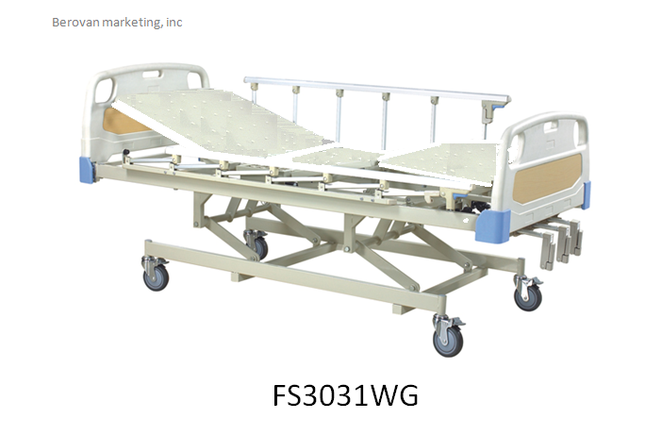

**PRICE @ 32,000.00**

Manual 3 functions Hospital Bed with Metal Sheet Panel (Metal Board)

With powder coating steel frame

Head and foot part is made of ABS plastic

With pedal locking castors

Optional Accessories: Mattress, Food Table and IV Pole

Overall size: 212X96

Dimensions:

