HOSPITAL BED FS3031WG

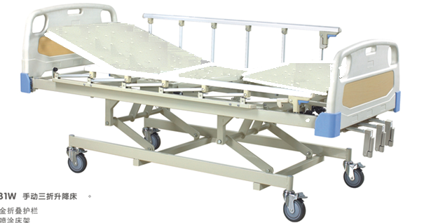

MANUAL THREE FUNCTIONS, METAL NET PANEL

●POWDER COATING STEEL FRAME

●PEDAL LOCKING CASTORS

Central Control Locking Castor

Metal Board

* OPTIONAL ACCESSORIES:MATTRESS,FOOD TABLE,I.V.POLE

Dimensions:



