Hospital Bed FS3031WG

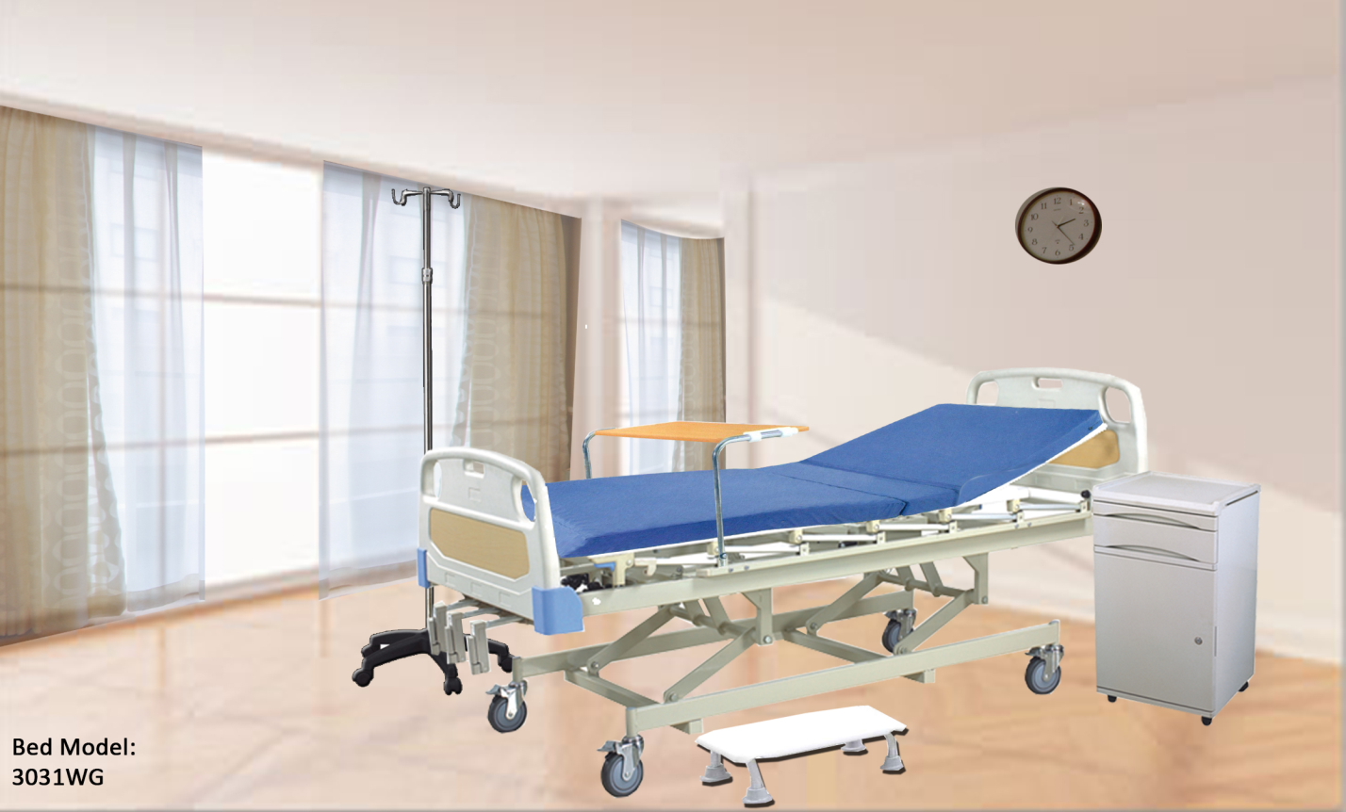

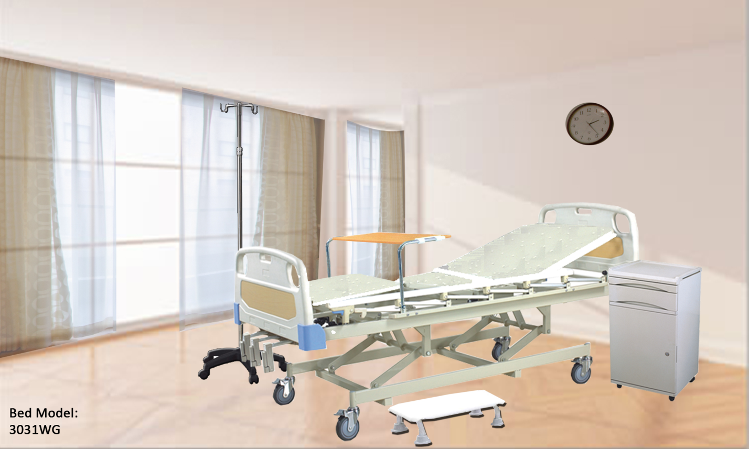

MANUAL THREE FUNCTIONS, METAL NET PANEL

●POWDER COATING STEEL FRAME

●PEDAL LOCKING CASTORS

Central Control Locking Castor

Metal Board

Dimensions:



