
BEROVAN MARKETING, INC.
------------------------------------------------------------------------------------------------------------
<Date>

____________
____________
____________

Dear Doctor,

In compliance with your request, we are submitting herewith our price quotation on the said equipments for your consideration and guidance.

Model | Description | Price
Philips Avalon FM20  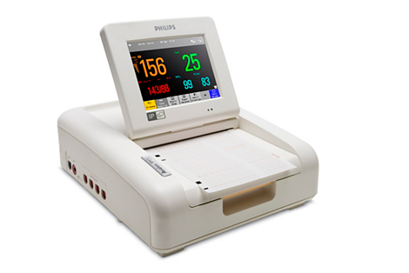 | FETAL MONITOR PHILIPS AVALON FM20  Specifications:  - 6.5" TFT color touchscreen tilt-and-fold display  - Used for antepartum and intrapartum  - With optional maternal ECG & NIBP measurement  - With watertight and repairable transducers  - Ultrasound type/frequency - Pulsed Doppler/1 MHz (±100 Hz)  - Standard twin capability and optional triplet monitoring  - With automated maternal heart rate and fetal heart rate coincidence detection  - With fetal movement profile that auto detects fetal movements  - With cross-channel verification to avoid picking up 1 FHR with both US transducers or the MHR with the US transducer  - Selectable offset on twin FHR and triplet FHR  - Maternal heart rate is measured via optional ECG electrodes  - Maternal pulse is measured via NIBP and toco transducer  - With audible and visual alarms  - With big numeric dynamic display and smart keys for quick access to functions  - The fetal sensor sockets have transducer auto-recognition  - Alarms available - High/low FHR, coincidence alarm, reminder alarm, latching alarm  - With integrated recorder. The channels available are FHR1, FHR2, FHR3, Uterine Activity, Fetal Movement Profile, Maternal heart rate/pulse  - Selectable paper speed are 1, 2 & 3cm/min  - With event marker  - Transducer finder LED for easy identification and repositioning.  - Analog-to-digital conversion and subsequent processing of raw signals in the transducer instead on the fetal monitor  - With internal back-up memory up to 7 hours  - Capable of connection to a remote obstetrical surveillance and information management system  - With demo mode to support staff training  - With NST timer  - Optional antepartum trace interpretation (NST) software that analyzes traces based on NICHD 2008 CTG guidelines  - Weight in kg <5.3 with battery  - With optional rechargeable lithium-ion battery  - Capable of connecting to a wireless/cable-less transducer system  - Battery operating time – >4 hours  - Computer interface available - RS232, LAN interface, data export interface, nurse call interface | FM20 WIRED FETAL MONITOR TWINS(basic only, no maternal parameters)  SRP:  308,000.00 /unit

PRICE VALIDITY: Thirty (30) Days

DELIVERY: 90-120 days after PO receipt.

TERMS OF PAYMENT: 30 days

We hope our office will meet your kind and favorable approval and we look forward in receiving your most valued order soon.

Thank you, we remain.

Respectfully yours,

PSSR Name

