**EXAMINATION TABLE, GYNAE, CABINET & DRAWERS**

Product Code: **44-197-03**

**Description**

* 2 section Examination Table fitted with 50mm mattress covered with washable vinyl fabric.
* Frame made form M.S. square section pipe and CRCA sheet.
* Main body fitted with 3 Drawers and 3 Utility Cabinets.
* Fitted with an adjustable tray on the side for a B.P. apparatus.
* Perineal cut provided at the foot section.
* Back-rest adjustable by pneumatic pump.
* All metal components pre-treated and epoxy powder coated.
* Legs fitted with PVC / rubber stumps.
* Provided with2 adjustable Knee Crutches.

**Options:** At extra cost. Please specify when enquiring / ordering.

(A) A recessible footstep for patient’s convenience. (See inset pic.)

**Dimensions:**

* Approx. 1870 x 560 x 810mm (L x W x H).

**Shipping:** Assembled.

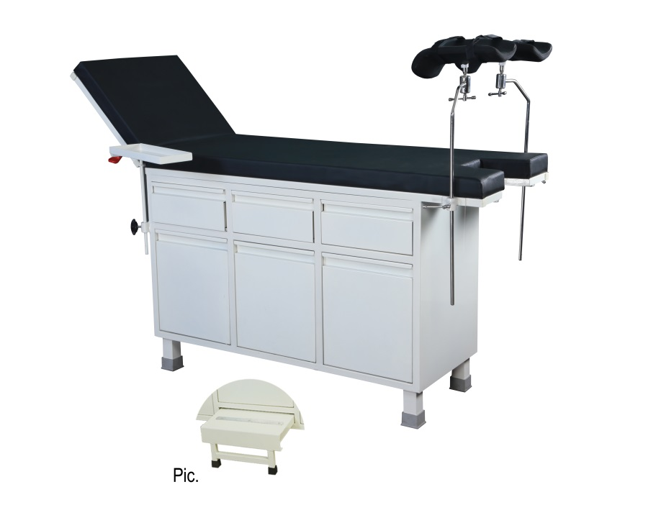

KICK BUCKET, EPC

Product Code: 44-160

**Description**

* M.S. tubular pipe frame, mounted on 3 x 75mm swivel castors.
* Supplied with stainless steel Bucket.
* All metal parts pre-treated and epoxy powder coated.

**Dimensions:**

* Approx. 300 x 300mm (H* x D).
* *Height up to ring.

**Shipping:** Assembled.

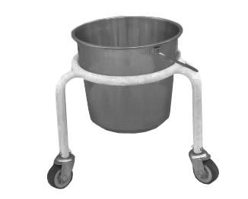

DOCTOR’S STOOL, GAS SPRING

Product Code: 44-155-01

**Description**

* Revolving stool mounted on a polyurethane base fitted with 5 x 50mm swivel castors.
* Height adjustable by means of a gas spring.
* Upholstered cushioned top for comfort.

**Dimensions:**

* Seat dia.: Approx. 380mm.
* Lift: Approx. 120mm

**Shipping:** Assembled.

