**Obstetric Electric Bed (B-48-1)**

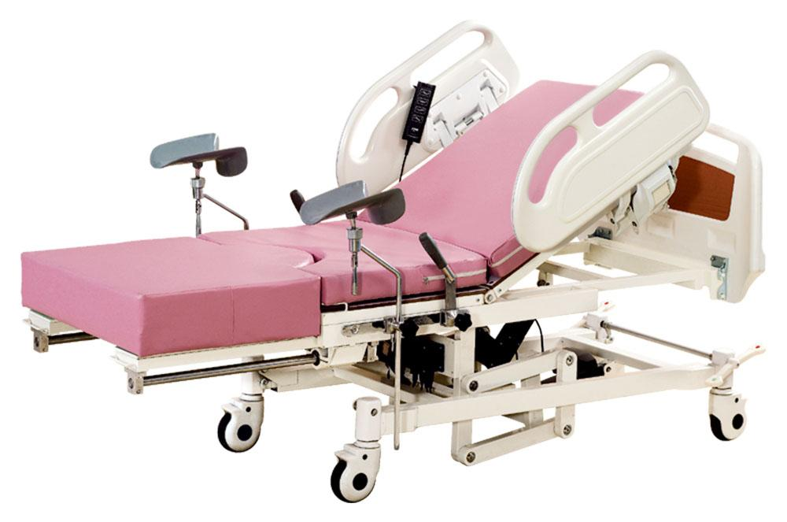

Description :

Obstetric electric bed SIZE: L2000/1450× W900/660× H620/920mm

1. Adopting linear bearing to control the telescopic working table.

2. High quality ABS engineering plastic detachable headboards are beautiful and generous, which can be freely installed and removed and stable.

3. Bed frame welded by profile steel are stable and reliable.

4. High quality ABS engineering plastic tuck-away side rails are beautiful and generous, easy to operate.

5.125mm dia. Castors with central locking system make the bed move flexibly, lightly and conveniently.

6. Equiped with 8cm thickness high density sponge mattress covered with artificial leather.

7. Adjustable leg support and sliding grip holder.

8. It adopts imported safe voltage motor.

9. Reverse trendelenburg 0-12° , height adjustable 620-920mm.

Main Feature:  
1. Epoxy coated steel bed frame , with ABS engineering plastic side and head board;  
2. Telescopic working table , to be controlled by linear bearing, telescopic length :550mm;  
3. Three function , which are operated by electric motor :  
1) back rest:0-70±5º  
2) high-low:620-920mm  
3) trendelenburg & reverse trendelenburg 12±2º  
4. Equiped with 8cm thickness high density sponge mattress covered with artificial leather.  
5. Adjustable leg support and sliding grip holder.  
6. Four dia-125mm castors, which are with central brakes