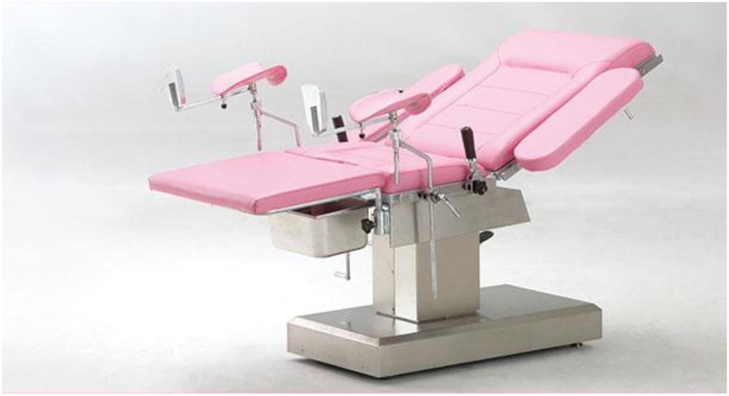HEBEIPUKANGMEDICALINSTRUMENTSCO.,LTD

INSTRUCTION FOR USE

Hospital Manual Bed and Model: B-45





Please read the operation manual carefully before use.

People’s Republic of China

(Date of Issue 30-06-20)

HEBEI PUKANG MEDICAL INSTRUMENTS CO., LTD



DONGSHIDUANTOWNXUSHUICOUNTYHEBEIPROVINCECHINA

HEBEIPUKANGMEDICALINSTRUMENTSCO.,LTD

1. Usageandintroduction:

The B-45 hospital electric bed is used for obstetric; it is designed according to the needs on the

marketanddeliverydoctor’ssuggestions. It’ssuitablefortheordinaryoperationsandwomen’s

parturition,alsoforthegynecologicaldialogandexamination.Itischaracterizedbyversatility,easy

operation,safetyandreliability.It use the electric equipment produced by the manufacturer which has international authentication qualificatory. Improved the production and inspection process. The product has reached to the international level in safty, practicability, comfort ability, which has set the basement for the entrance to the international market.

Environment & Condition

a) store environment：

1 . temperature： －10°Cto50°C；   

   2.relativehumidity：≤85%；

   3.atmosphericpressure：70Kpa～106Kpa；

b) operation environment：

   1.temperature： 5°Cto40°C；   

2.relativehumidity：≤85%；

   3.atmosphericpressure：70Kpa～106Kpa；

2. Specification: 

Tableatthelowestlevel≤695mm

Tableelevatingstroke≥280mm

Maxreversedtrendelenburg ＞8°

Maxtrendelenburg ＞20°

Backsection—raisedfromthehorizontal ＞60°

Backsection—loweredfromthehorizontal ＞6°

Overalllength:1240mm

Overallwidth:600mm

3. Usingintroduction: 

A.Asendinganddescendingofthebed: 

  The ascending and descending of the bed is controlled by electric controller. When needing toascend the bed, please consequently press the electric controller up. When needing todescendit,pleasepressthecontroller down,thetablecanslowlydescenddown.

NOTE:whenpressingit,pleasedon’tusetoofarpower

B.  Reversedtrendelenburgandtrendelenburgofthebed:

It is controlled by the electric control, when operating it; you can make the bed to the variouspositionofreversedtrendlenburg8degreesandtrendlenburg20degrees.C.  Theadjustmentofbackrest:

Theupwardanddownwardofthebackrestarecontrolledbyelecteric controller down button,whenoperatingit;

DONGSHIDUANTOWNXUSHUICOUNTYHEBEIPROVINCECHINA