***ALS-MT116    Hospital emergency treatment trolley***

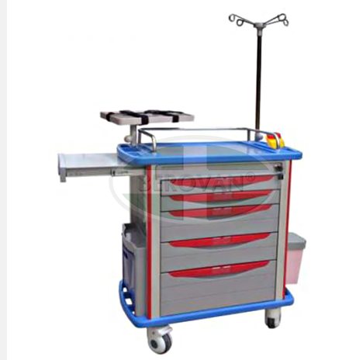

**Specifications**

Emergency treatment trolley   
1 Material: ABS   
2 one drawer   
3 Stainless steel guardrail   
4 four castors, two with brakes 

***Description of product:***

**Features:**

1. One-piece ABS plastic top board with arc handle and raised-edge design , covered  
transparent soft plastic glass  
2. Stainless steel guard rail  
3. Dust basket, Utility container, Needle disposal holder ,Sliding side shelf  
4. IV pole, Defibrillator shelf, C.P.R Board (Cardiac Massage Table), Power outlet &Hooks,  
   Oxygen Cylinder Holder.  
5. Centralized lock  
6. Four luxurious noiseless casters, two with brakes  
7. High-quality aluminum columns  
8. Label cards for drawers