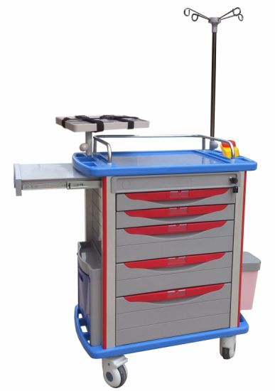

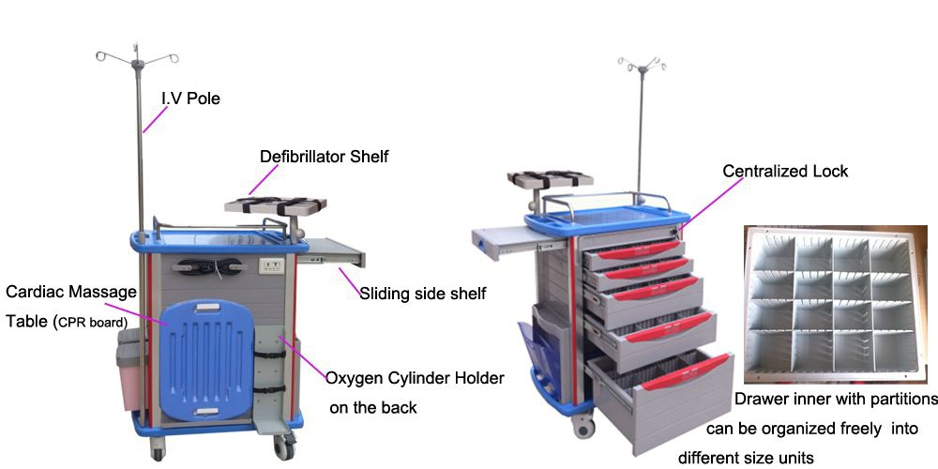

ALS-MT116
Size: 750*475*920mm

ACCESSORIES & DETAILS:
- One-piece ABS plastic top board with arc handle and raised-edge design ， covered
transparent soft plastic glass
- Stainless steel guard rail
- Dust basket, Utility container, Needle disposal holder ,Sliding side shelf
- IV pole, Defibrillator shelf, C.P.R Board (Cardiac Massage Table), Power outlet&Hooks,
Oxygen Cylinder Holder.
- Centralized lock
- Four luxurious noiseless casters, two with brakes
- High-quality aluminum columns
- Label cards for drawers
- Five ABS drawers:1 big,2 small drawers and 2 middle drawers (each inner with partitions can
be organized freely into different size units)

