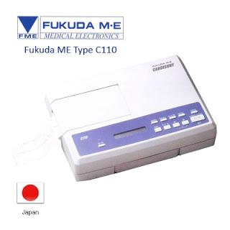

ECG C110

[**Cardisuny C110**](http://umaraleksana.co.id/)

[ECG](http://umaraleksana.co.id/) [1 or 2 channel](http://umaraleksana.co.id/), [Digital Electrocardiograph](http://umaraleksana.co.id/)  
Durable and compact design, easy operation and High resolution printout.

**Specification :**

* Automatic or manual recording.
* Weight only 2 Kg.
* Can be operated by AC and built in rechargeable battery.
* High resolution printout on roll paper and z-fold paper.
* LCD display.
* Button switch.

Automatic / Manual recording  
1 or 2-ch recording  
3 sec. to 10 sec. lead recording time  
Digital filter: AC interference, Muscle and Base line drift  
LCD display: Lead, H.R (BPM) and Battery low indication  
Alarms: Electrode OFF, R-wave detection error, Paper error  
Auto P-wave recording start  
Auto base line positioning