

**DRESSING CART YKK005**

**STAINLESS STEEL**

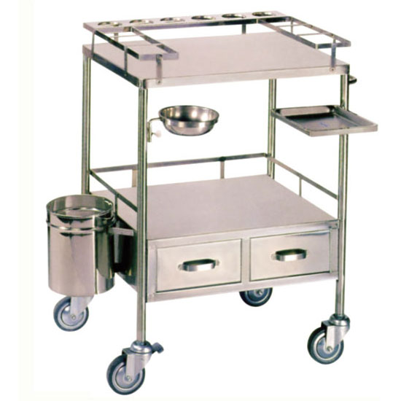

* With Jars
* With Bowl
* With Garbage bin
* With Tray
* With 2 drawers
* Wheels with break