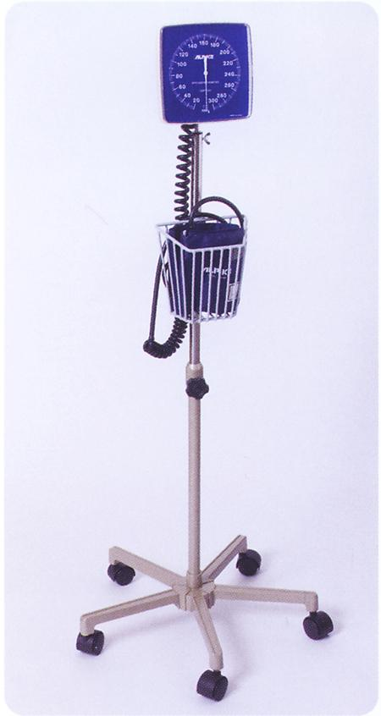

§ **SPHYGMO ANEROID STAND TYPE ALPK2 500W3**

**(ADULT)**

Product Specifications:

§ Mobile Unit: 5 Legs Base Unit with Caster

§ Weight: 5.0 kg

Made in Japan