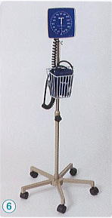 | ・Mobile Unit : 5-Legs Base Unit with Caster  ・Other Specifications : same as No.500-W-1  ・Weight : 5.0 Kg  ・Packing : 4 sets/carton  : 0.0787m³, 22.0kg
No. W500-3

