colro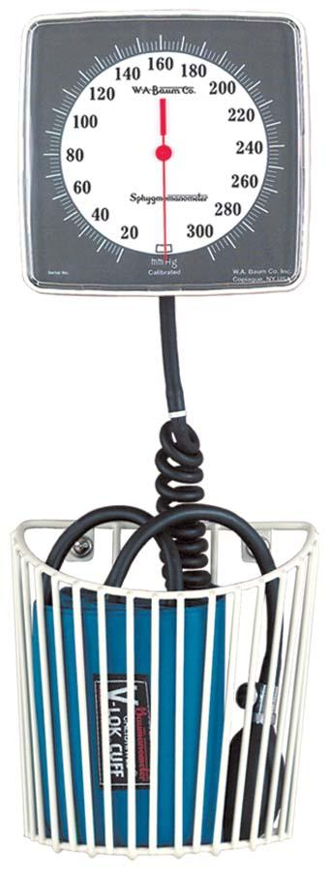[**5**](http://www.wabaum.com/items.aspx?id=77)

**Baum Wall Aneroid (0950)**

|  |  |
| --- | --- |
| |  | | --- | | Description   * 300 mmHg swivel-type (110° arc) clinical sphygmomanometer for wall mounting. * Meets the American National Standard ANSI/AAMI SP-10 for accuracy and performance. * Available with Latex or Non-Latex components. * Neutral White ABS plastic manometer with chrome plated steel bracket. * Unique high contrast scale and red pointer increase visibility and reduce parallax error. * 2 convenient cuff storage options available: large basket or small basket. * Calibrated® V-Lok® inflation System with 8 feet of Extendex® Tubing.   Instrument Finish:   * Neutral White ABS Plastic.   Instrument Dimensions:   * 61⁄4” L x 61⁄4” W x 4” H   Packaged Dimensions:   * 105⁄8” L x 71⁄4” W x 71⁄2” H   Basket Color:   * Neutral White (standard)   Instrument Weight:   * 1.10 lbs.   Packaged Weight:   * 3.25 lbs   Cuff Size:   * Adult   Inflation System:   * Calibrated® V-Lok   Holder:   * Wall Basket (Nylon Coated Steel) | |
|  |