**Bauma Products**

[**12**](http://www.wabaum.com/items.aspx?id=18~)

**Baum Pocket Aneroid (1050)**

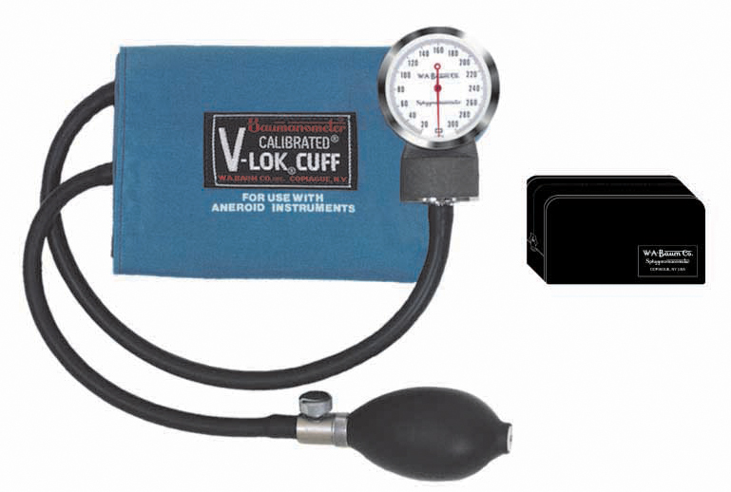

|  |  |
| --- | --- |
| |  | | --- | | **Baum Pocket Aneroid**  Description   * 300 mmHg clinical sphygmomanometer for portable use. * Meets the American National Standard ANSI/AAMI SP-10 for accuracy and performance. * Available with Latex or Non-Latex components. * Diecast zinc manometer housing. * Precision low friction movement with twin pre-seasoned phosphor-bronze diaphragm capsules. * Unique high contrast scale and red pointer for increased visibility and reduced parallax error. * Calibrated® V-Lok® inflation System   Finish:   * Warm Gray textured baked enamel   Packaged Dimensions:   * 81⁄2” L x 47⁄8” W x 21⁄2” H   Packaged Weight:   * 1.05 lbs.   Standard Cuff Color:   * Medium Blue   Cuff Size:   * Adult   Inflation System:   * Calibrated® V-Lok®.   Holder: Zippered Case | |
|  |



**The Baum Stainless Steel Cardiology Stethoscope (2730)**

**The Baum Stainless Steel Cardiology Stethoscope**

* Designed for cardiology.
* Built to our unique specifications.
* Delivers superior acoustic sensitivity.

Features

* Precision machined stainless steel dual head chestpiece, valve stem and binaural.
* A dual binaural spring is incorporated inside the tubing to reduce bulk and weight.
* Non-chill rings are fitted to the diaphragm and deep cone shaped bell receivers for patient comfort.
* Soft eartips ensure a comfortable, correct fit.
* Two separate channels in one piece of black non-latex tubing.
* Extra eartips and a replacement diaphragm are included.

Packaged Dimensions:

* 113⁄4” L x 61/3” W x 11⁄2” H

Packaged Weight:

* .78 lbs.

Product Specifications

* Length - 27"
* Tubing Color - Black
* Chestpiece - Stainless Steel

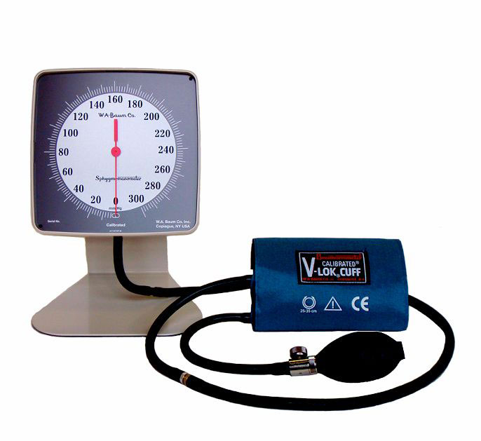

**Baum Desk Aneroid (0920)**

**Baumanometer® Desk Aneroid Description**

* 300 mm Hg Aneroid instrument mounted at a 20º angle for ease of viewing.
* Complies with ANSI/AAMI SP-10 for accuracy and performance (1% full scale + / - 3 mm Hg).
* Neutral White ABS plastic manometer with chrome plated steel bracket.
* Available with Latex or Non-Latex components.
* Unique high contrast scale and red pointer increase visibility and reduce parallax error.
* Manufactured with a low-friction precision movement and twin pre-seasoned phosphor-bronze diaphragm capsules.
* Calibrated® V-Lok® inflation System.

Finish:

* Neutral Gray textured baked enamel with non-skid base.

Instrument Dimensions:

* 6.25" H x 6.25" W x 4" D

Packaged Dimensions:

* 10 5/8” L x 7 ¼” W x 7 ½” D.

Standard Cuff Color:

* Medium Blue

Weight:

* 3.25 lbs.

Packaged Weight:

* 3.25 lbs.

Cuff Size:

* Adult

Inflation System:

* Calibrated® V-Lok®

Calibration

* 300 mmHg

CALIBRATED® V-LOK® INFLATION SYSTEM

* **Consits of:** Bulb, Air-Flo® Control Valve, Inflation Bag and Calibrated® V-Lok® Cuff.
* **Accurate:** The Calibrated®V-Lok® system immediately indicates whether or not the correct size cuff is being used. The center of the bladder is clearly marked on the inner and outer surfaces of the cuff for correct application on either the right or left limb.
* **Comfortable:** Cuffs conform to the shape of the limb and have no hard, stiff edges.
* **Durable:** Baum cuffs are made of tightly woven, heat set Dacron™ polyester fabric. They are double stitched at critical points for long wear and treated with an effective anti-microbial agent. Hook and loop fasteners of matched holding strength provide the optimal number of open-close cycles
* **Non-Latex:** Available for those who are hypersensitive to natural rubber latex.
* **Guaranteed:** Latex and Non-Latex inflation bags, bulbs and tubing are guaranteed for five years.

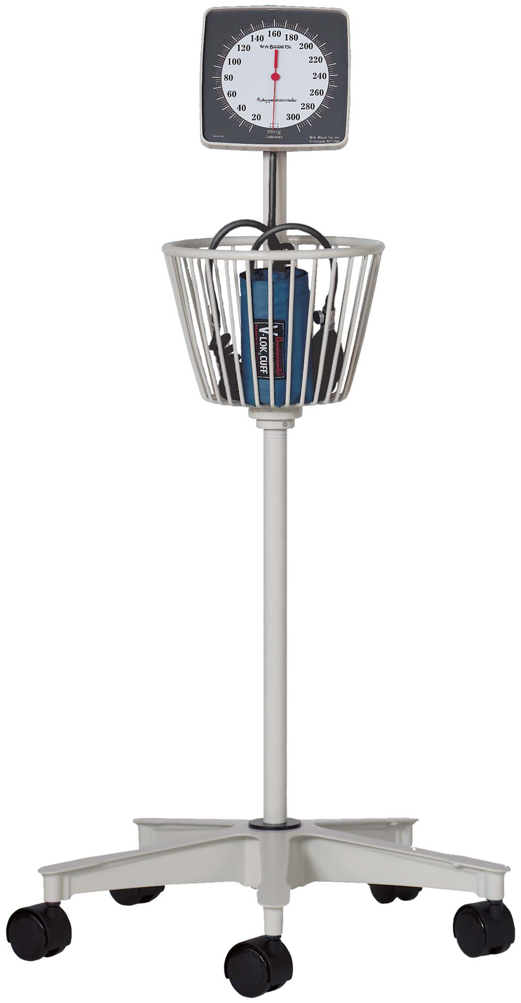

[**5**](http://www.wabaum.com/items.aspx?id=42~)

**Baum Roll-By® Mobile Aneroid (1150)**

**Baum Roll-By® mobile aneroid**

Description

* 300 mmHg clinical sphygmomanometer for mobile use.
* Meets the American National Standard ANSI/AAMI SP-10 for accuracy and performance.
* Available with Latex or Non-Latex components.
* Unique, low reflection, high contrast scale and red pointer to increase visibility and reduce parallax error.
* Diecast aluminum 5-wheel base(20”dia.) with 2”hooded casters and 2lb. cast iron weight for increased stability.
* Manometer housing is mounted at a 20° angle for ease of viewing.
* Heavy gauge machined aluminum tubing.
* Calibrated® V-Lok® inflation System and 8 feet of Extendex® coiled tubing.

Baum Roll-By® model 1150 - Large Basket

* The Baum Roll-By® model 1150 has a large circular (360°) basket to store a full complement of inflation systems.

Finish:

* Neutral White ABS plastic

Packaged Dimensions:

* 22” L x 211⁄2” W x 151⁄4” H

Packaged Weight:

* 17.70 lbs.

Standard Cuff Color:

* Medium Blue

Cuff Size:

* Adult

Inflation System:

* Calibrated® V-Lok®

Cuff Holder:

* Large Circular Basket

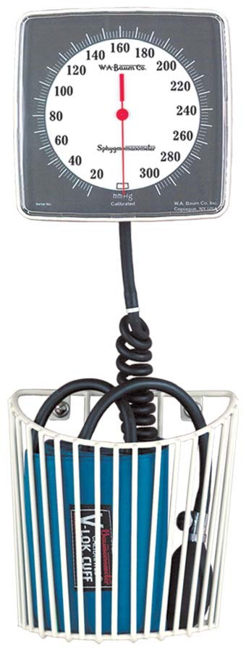

[**1**](http://www.wabaum.com/items.aspx?id=77~)

**Baum Wall Aneroid (0950)**

Description

* 300 mmHg swivel-type (110° arc) clinical sphygmomanometer for wall mounting.
* Meets the American National Standard ANSI/AAMI SP-10 for accuracy and performance.
* Available with Latex or Non-Latex components.
* Neutral White ABS plastic manometer with chrome plated steel bracket.
* Unique high contrast scale and red pointer increase visibility and reduce parallax error.
* 2 convenient cuff storage options available: large basket or small basket.
* Calibrated® V-Lok® inflation System with 8 feet of Extendex® Tubing.

Instrument Finish:

* Neutral White ABS Plastic.

Instrument Dimensions:

* 61⁄4” L x 61⁄4” W x 4” H

Packaged Dimensions:

* 105⁄8” L x 71⁄4” W x 71⁄2” H

Basket Color:

* Neutral White (standard)

Instrument Weight:

* 1.10 lbs.

Packaged Weight:

* 3.25 lbs

Cuff Size:

* Adult

Inflation System:

* Calibrated® V-Lok

Holder:

* Wall Basket (Nylon Coated Steel)

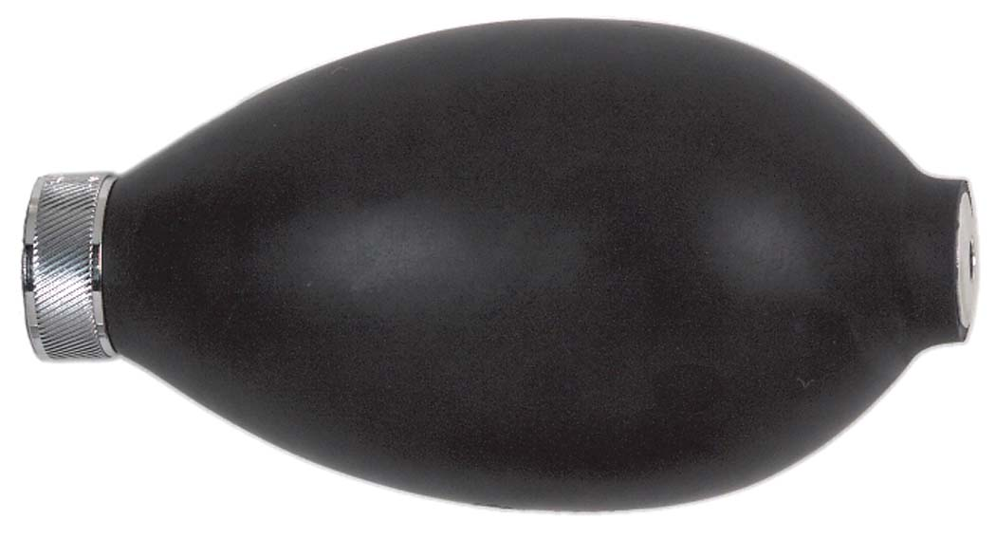 [**4**](http://www.wabaum.com/items.aspx?id=122~)

**Baum Bulb (1891)**

**Baum Bulb Only**

This pressure source for all sphygmomanometers consists of the Baum Latex or Non-Latex Bulb and Air-Flo® Control Valve.

Note:

* All Latex items are natural rubber Latex.

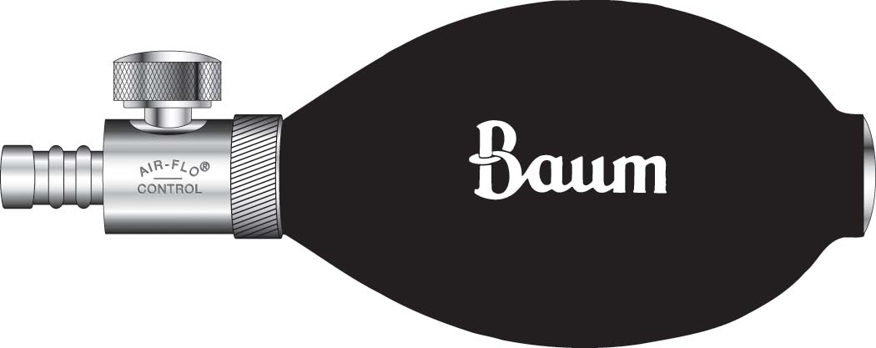

[**7**](http://www.wabaum.com/items.aspx?id=121~)

**Baum Bulb and Air-Flo® Control Valve (1890)**

**Baum Bulb and Air-Flo® Control Valve**

This pressure source for all sphygmomanometers consists of the Baum Latex or Non-Latex Bulb and Air-Flo® Control Valve

The Baum Air-Flo® Control Valve

* Instantly responsive
* Smooth operating and long wearing
* Conical valve seat is inegral with the valve body, it cannot loosen and cause leakage.
* Valve body is solid brass, first nickel then chrome plated.
* All key interior parts are stainless steel for corrosion-free, non-stick operation

These are just some of the features which make Baum Air-Flo® Control Valve The standard by which others are judged.

Note:

* All Latex items are natural rubber Latex.

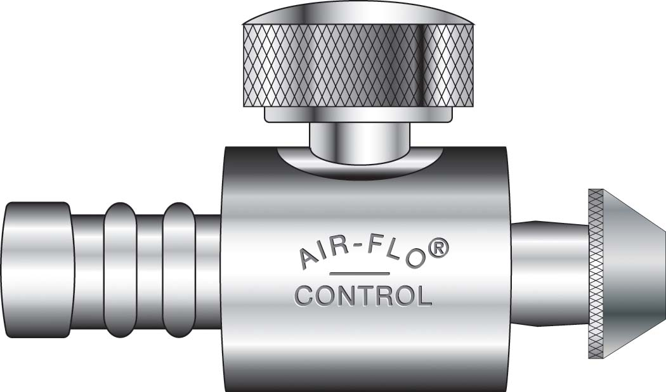

[**3**](http://www.wabaum.com/items.aspx?id=123~)

**Air-Flo® Control Valve (1892)**

|  |
| --- |
|  |
| **Air-Flo® Control Valve**  This pressure source for all sphygmomanometers consists of the Baum Latex or Non-Latex Bulb and Air-Flo® Control Valve  The Baum Air-Flo® Control Valve   * Instantly responsive * Smooth operating and long wearing * Conical valve seat is inegral with the valve body, it cannot loosen and cause leakage. * Valve body is solid brass, first nickel then chrome plated. * All key interior parts are stainless steel for corrosion-free, non-stick operation   These are just some of the features which make Baum Air-Flo® Control Valve The standard by which others are judged.  Note:   * All Latex items are natural rubber Latex. |



[**2**](http://www.wabaum.com/items.aspx?id=130~)

**Inflation Bags (Double Tube) (1840)**

**Inflation Bags (Double Tube)**

* Available in Latex or Non-Latex
* Made of smooth, soft, dipped natural rubber latex or neoprene for seamless construction.
* Anti-oxidants and anti-ozonants are added to the mixture to prevent accelerated aging.
* Latex and Non-Latex inflation bags are guaranteed for five years.

Size:

* Adult

Description:

* Inflation Bag

Dimensions:

* 12 cm x 23 cm



[**0**](http://www.wabaum.com/items.aspx?id=131~)

**Inflation Bags (Double Tube) (1841)**

**Inflation Bags (Double Tube)**

* Available in Latex or Non-Latex
* Made of smooth, soft, dipped natural rubber latex or neoprene for seamless construction.
* Anti-oxidants and anti-ozonants are added to the mixture to prevent accelerated aging.
* Latex and Non-Latex inflation bags are guaranteed for five years.

Size:

* Child/Small Adult

Description:

* Inflation Bag

Dimensions:

* 9 cm x 18 cm



[**0**](http://www.wabaum.com/items.aspx?id=132~)

**Inflation Bags (Double Tube) (1842)**

|  |
| --- |
|  |
| **Inflation Bags (Double Tube)**   * Available in Latex or Non-Latex * Made of smooth, soft, dipped natural rubber latex or neoprene for seamless construction. * Anti-oxidants and anti-ozonants are added to the mixture to prevent accelerated aging. * Latex and Non-Latex inflation bags are guaranteed for five years.   Size:   * Infant   Description:   * Inflation Bag   Dimensions:   * 6 cm x 12 cm |



[**1**](http://www.wabaum.com/items.aspx?id=135~)

**Inflation Bags (Double Tube) (1845)**

**Inflation Bags (Double Tube)**

* Available in Latex or Non-Latex
* Made of smooth, soft, dipped natural rubber latex or neoprene for seamless construction.
* Anti-oxidants and anti-ozonants are added to the mixture to prevent accelerated aging.
* Latex and Non-Latex inflation bags are guaranteed for five years.

Size:

* Large Arm

Description:

* Inflation Bag

Dimensions:

* 15 cm x 33 cm



[**0**](http://www.wabaum.com/items.aspx?id=133~)

**Inflation Bags (Double Tube) (1843)**

**Inflation Bags (Double Tube)**

* Available in Latex or Non-Latex
* Made of smooth, soft, dipped natural rubber latex or neoprene for seamless construction.
* Anti-oxidants and anti-ozonants are added to the mixture to prevent accelerated aging.
* Latex and Non-Latex inflation bags are guaranteed for five years.

Size:

* Newborn

Description:

* Inflation Bag

Dimensions:

* 2.5 cm x 5 cm

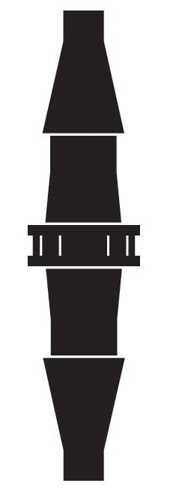

[**0**](http://www.wabaum.com/items.aspx?id=413~)

**Connectors (2924)**

|  |
| --- |
|  |
| **Connectors**  Description:   * Straight Connector |

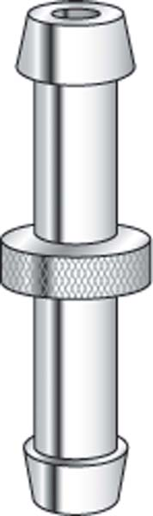

[**1**](http://www.wabaum.com/items.aspx?id=414~)

**Connectors (2935)**

**Connectors**

Description:

* Connector, Extendex®-to-Straight Tubing

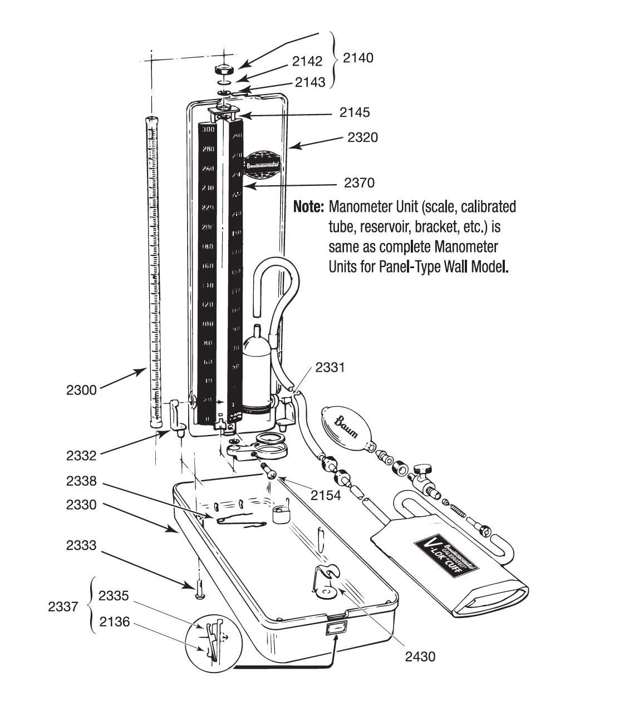

[**2**](http://www.wabaum.com/items.aspx?id=416~)

**Repair Parts For Baumanometer® Desk Model**

**Repair Parts For Baumanometer® Desk Model**

Cat. No.             Description

* 2136                Leaf spring for lock push plate for Desk Model
* 2140                Knurled cap complete for Desk Model
* 2142                Diaphragm filter for Desk Model
* 2143                Leather cap washer for Desk Model
* 2145               Silicone rubber tube washer for Desk Model
* 2150               Complete reservoir and bracket assembly for Desk Model
* 2154               Bracket screw for Desk Model
* 2300               Mylar® Clad Cartridge Tube for Desk Model (300 mmHg)
* 2320               Cover Only for Desk Model
* 2330               Case Only for Desk Model
* 2331               Hinge Post, right hand for Desk Model
* 2332               Hinge Post, left hand for Desk Model
* 2333               Screw for hinge post for Desk Model
* 2334               Hinge posts, pair, with screws for Desk Model
* 2335               Lock push plate for Desk Model
* 2337              Complete lock for Desk Model
* 2338               "Z" Spring for cover for Desk Model
* 2370               Scale only for Desk Model
* 2430               Bulb holder for Desk Model

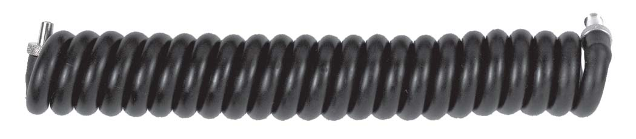 [**3**](http://www.wabaum.com/items.aspx?id=407~)

**Latex Tubing (2919)**

**Extendex® Tubing**

All tubing is available in Latex or Non-Latex. In ordering tubing for our various models, follow this guide:

* Kompak, Desk, hi/Lo®                   2 ft. straight
* Standby®                                         4 ft. Extendex®
* Panel Wall, Wall unit 33, Roll-By®, Wall aneroid 8 ft. Extendex®

Description:

* Extendex® Tubing (4 ft) with connectors

http://www.wabaum.com/catalogimages/154.jpg

[**3**](http://www.wabaum.com/items.aspx?id=154~)

**Calibrated® V-Lok® Cuff (1870)**

**Calibrated® V-Lok® Cuff**

* **Accurate:** The Calibrated®V-Lok® system clearly indicates whether or not the correct size cuff is being used. The center of the bladder is clearly marked on the inner and outer surfaces of the cuff for correct application on either the right or left limb. Hook and loop fasteners are used to provide the optimal number of open-close cycles.
* **Comfortable:** Cuffs conform to the shape of the limb and have no hard, stiff edges.
* **Durable:** Baum cuffs are made of tightly woven, heat set Dacron™ polyester fabric. They are double stitched at critical points for long wear and treated with an effective anti-microbial agent.
* **Non-Latex:** Available for those who are hypersensitive to natural rubber latex.
* **Guaranteed:** Latex and Non-Latex inflation bags, bulbs and tubing are guaranteed for five years.

* Cuff sizes are made to fit dimensions of corresponding size inflation bags for limb circumference shown.

Size:

* Adult

Standard Cuff Color:

* Medium Blue

Color Coded Cuffs:

* Newborn - *Gray*; Infant - *Tan*; Child - *Dark Green*; Adult - *Medium Blue*; Large Arm - *Scarlet;*Thigh - *Dark Brown*

Color Codes:

* **G** - Gray    **T** - Tan    **DG** - Dark Green    **MB** - Medium Blue    **S** - Scarlet    **DB** - Dark Brown

Calibrated® V-Lok®:

* Cuff Only

Limb Circumference:

* 25 cm to 35 cm

http://www.wabaum.com/catalogimages/154.jpg

[**3**](http://www.wabaum.com/items.aspx?id=154~)

**Calibrated® V-Lok® Cuff (1870) BROWN/GREEN/RED**

|  |
| --- |
|  |
| **Calibrated® V-Lok® Cuff**   * **Accurate:** The Calibrated®V-Lok® system clearly indicates whether or not the correct size cuff is being used. The center of the bladder is clearly marked on the inner and outer surfaces of the cuff for correct application on either the right or left limb. Hook and loop fasteners are used to provide the optimal number of open-close cycles. * **Comfortable:** Cuffs conform to the shape of the limb and have no hard, stiff edges. * **Durable:** Baum cuffs are made of tightly woven, heat set Dacron™ polyester fabric. They are double stitched at critical points for long wear and treated with an effective anti-microbial agent. * **Non-Latex:** Available for those who are hypersensitive to natural rubber latex. * **Guaranteed:** Latex and Non-Latex inflation bags, bulbs and tubing are guaranteed for five years.      * Cuff sizes are made to fit dimensions of corresponding size inflation bags for limb circumference shown.   Size:   * Adult   Standard Cuff Color:   * Medium Blue   Color Coded Cuffs:   * Newborn - *Gray*; Infant - *Tan*; Child - *Dark Green*; Adult - *Medium Blue*; Large Arm - *Scarlet;*Thigh - *Dark Brown*   Color Codes:   * **G** - Gray    **T** - Tan    **DG** - Dark Green    **MB** - Medium Blue    **S** - Scarlet    **DB** - Dark Brown   Calibrated® V-Lok®:   * Cuff Only   Limb Circumference:   * 25 cm to 35 cm   http://www.wabaum.com/catalogimages/156.jpg |

**Calibrated® V-Lok® Cuff (1872)**

**Calibrated® V-Lok® Cuff**

* **Accurate:** The Calibrated®V-Lok® system clearly indicates whether or not the correct size cuff is being used. The center of the bladder is clearly marked on the inner and outer surfaces of the cuff for correct application on either the right or left limb. Hook and loop fasteners are used to provide the optimal number of open-close cycles.
* **Comfortable:** Cuffs conform to the shape of the limb and have no hard, stiff edges.
* **Durable:** Baum cuffs are made of tightly woven, heat set Dacron™ polyester fabric. They are double stitched at critical points for long wear and treated with an effective anti-microbial agent.
* **Non-Latex:** Available for those who are hypersensitive to natural rubber latex.
* **Guaranteed:** Latex and Non-Latex inflation bags, bulbs and tubing are guaranteed for five years.

* Cuff sizes are made to fit dimensions of corresponding size inflation bags for limb circumference shown.

Size:

* Infant

Standard Cuff Color:

* Medium Blue

Color Coded Cuffs:

* Newborn - *Gray*; Infant - *Tan*; Child - *Dark Green*; Adult - *Medium Blue*; Large Arm - *Scarlet;*Thigh - *Dark Brown*

Color Codes:

* **G** - Gray    **T** - Tan    **DG** - Dark Green    **MB** - Medium Blue    **S** - Scarlet    **DB** - Dark Brown

Calibrated® V-Lok®:

* Cuff Only

Limb Circumference:

* 10 cm to 19 cm

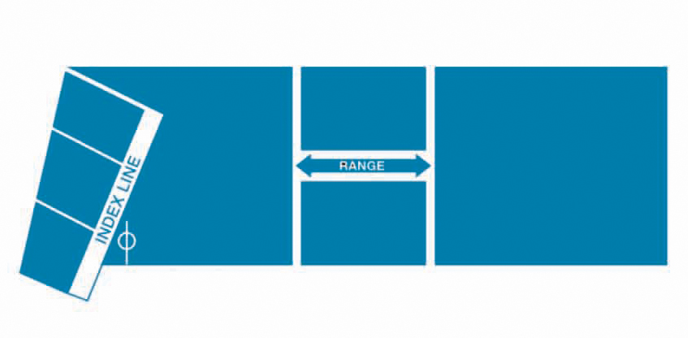**Calibrated® V-Lok® Cuff (1868)**

**Calibrated® V-Lok® Cuff**

* **Accurate:** The Calibrated®V-Lok® system clearly indicates whether or not the correct size cuff is being used. The center of the bladder is clearly marked on the inner and outer surfaces of the cuff for correct application on either the right or left limb. Hook and loop fasteners are used to provide the optimal number of open-close cycles.
* **Comfortable:** Cuffs conform to the shape of the limb and have no hard, stiff edges.
* **Durable:** Baum cuffs are made of tightly woven, heat set Dacron™ polyester fabric. They are double stitched at critical points for long wear and treated with an effective anti-microbial agent.
* **Non-Latex:** Available for those who are hypersensitive to natural rubber latex.
* **Guaranteed:** Latex and Non-Latex inflation bags, bulbs and tubing are guaranteed for five years.

* Cuff sizes are made to fit dimensions of corresponding size inflation bags for limb circumference shown.

Size:

* Large Arm

Standard Cuff Color:

* Medium Blue

Color Coded Cuffs:

* Newborn - *Gray*; Infant - *Tan*; Child - *Dark Green*; Adult - *Medium Blue*; Large Arm - *Scarlet;*Thigh - *Dark Brown*

Color Codes:

* **G** - Gray    **T** - Tan    **DG** - Dark Green    **MB** - Medium Blue    **S** - Scarlet    **DB** - Dark Brown

Calibrated® V-Lok®:

* Cuff Only

Limb Circumference:

* 33 cm to 47 cm



**Calibrated® V-Lok® Cuff (1871)**

**Calibrated® V-Lok® Cuff**

* **Accurate:** The Calibrated®V-Lok® system clearly indicates whether or not the correct size cuff is being used. The center of the bladder is clearly marked on the inner and outer surfaces of the cuff for correct application on either the right or left limb. Hook and loop fasteners are used to provide the optimal number of open-close cycles.
* **Comfortable:** Cuffs conform to the shape of the limb and have no hard, stiff edges.
* **Durable:** Baum cuffs are made of tightly woven, heat set Dacron™ polyester fabric. They are double stitched at critical points for long wear and treated with an effective anti-microbial agent.
* **Non-Latex:** Available for those who are hypersensitive to natural rubber latex.
* **Guaranteed:** Latex and Non-Latex inflation bags, bulbs and tubing are guaranteed for five years.

* Cuff sizes are made to fit dimensions of corresponding size inflation bags for limb circumference shown.

Size:

* Child/Small Adult

Standard Cuff Color:

* Medium Blue

Color Coded Cuffs:

* Newborn - *Gray*; Infant - *Tan*; Child - *Dark Green*; Adult - *Medium Blue*; Large Arm - *Scarlet;*Thigh - *Dark Brown*

Color Codes:

* **G** - Gray    **T** - Tan    **DG** - Dark Green    **MB** - Medium Blue    **S** - Scarlet    **DB** - Dark Brown

Calibrated® V-Lok®:

* Cuff Only

Limb Circumference: 18 cm to 26 cm