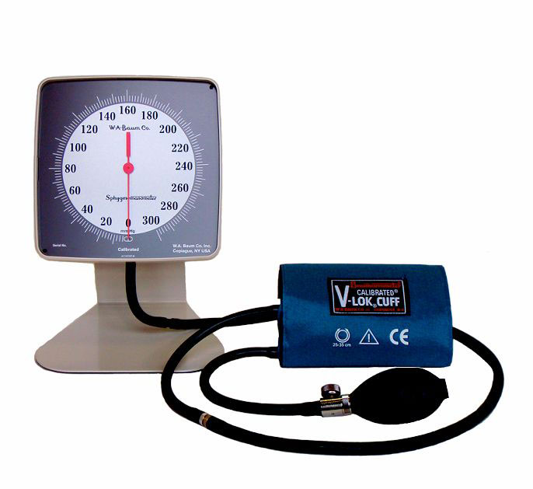

**Baumanometer® Desk Aneroid Description**

* 300 mm Hg Aneroid instrument mounted at a 20º angle for ease of viewing.
* Complies with ANSI/AAMI SP-10 for accuracy and performance (1% full scale + / - 3 mm Hg).
* Neutral White ABS plastic manometer with chrome plated steel bracket.
* Available with Latex or Non-Latex components.
* Unique high contrast scale and red pointer increase visibility and reduce parallax error.
* Manufactured with a low-friction precision movement and twin pre-seasoned phosphor-bronze diaphragm capsules.
* Calibrated® V-Lok® inflation System.

Finish:

* Neutral Gray textured baked enamel with non-skid base.

Instrument Dimensions:

* 6.25" H x 6.25" W x 4" D

Packaged Dimensions:

* 10 5/8” L x 7 ¼” W x 7 ½” D.

Standard Cuff Color:

* Medium Blue

Weight:

* 3.25 lbs.

Packaged Weight:

* 3.25 lbs.

Cuff Size:

* Adult

Inflation System:

* Calibrated® V-Lok®

Calibration

* 300 mmHg

CALIBRATED® V-LOK® INFLATION SYSTEM

* **Consits of:** Bulb, Air-Flo® Control Valve, Inflation Bag and Calibrated® V-Lok® Cuff.
* **Accurate:** The Calibrated®V-Lok® system immediately indicates whether or not the correct size cuff is being used. The center of the bladder is clearly marked on the inner and outer surfaces of the cuff for correct application on either the right or left limb.
* **Comfortable:** Cuffs conform to the shape of the limb and have no hard, stiff edges.
* **Durable:** Baum cuffs are made of tightly woven, heat set Dacron™ polyester fabric. They are double stitched at critical points for long wear and treated with an effective anti-microbial agent. Hook and loop fasteners of matched holding strength provide the optimal number of open-close cycles
* **Non-Latex:** Available for those who are hypersensitive to natural rubber latex.
* **Guaranteed:** Latex and Non-Latex inflation bags, bulbs and tubing are guaranteed for five years.