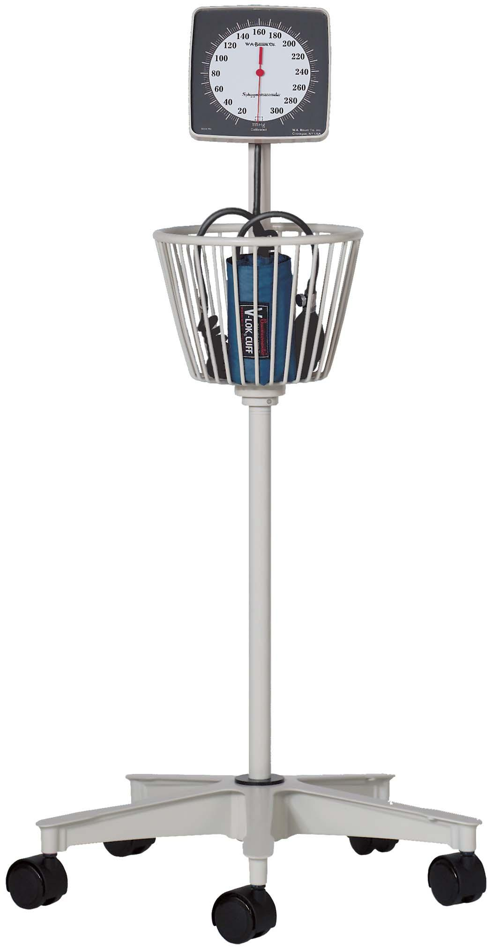

|  |  |
| --- | --- |
| |  | | --- | | **Baum Roll-By® mobile aneroid**  Description   * 300 mmHg clinical sphygmomanometer for mobile use. * Meets the American National Standard ANSI/AAMI SP-10 for accuracy and performance. * Available with Latex or Non-Latex components. * Unique, low reflection, high contrast scale and red pointer to increase visibility and reduce parallax error. * Diecast aluminum 5-wheel base(20”dia.) with 2”hooded casters and 2lb. cast iron weight for increased stability. * Manometer housing is mounted at a 20° angle for ease of viewing. * Heavy gauge machined aluminum tubing. * Calibrated® V-Lok® inflation System and 8 feet of Extendex® coiled tubing.   Baum Roll-By® model 1150 - Large Basket   * The Baum Roll-By® model 1150 has a large circular (360°) basket to store a full complement of inflation systems.   Finish:   * Neutral White ABS plastic   Packaged Dimensions:   * 22” L x 211⁄2” W x 151⁄4” H   Packaged Weight:   * 17.70 lbs.   Standard Cuff Color:   * Medium Blue   Cuff Size:   * Adult   Inflation System:   * Calibrated® V-Lok®   Cuff Holder:   * Large Circular Basket | |
|  |