**[3](http://www.wabaum.com/items.aspx?id=18" \o "View more services" \t "_blank)**

**Baum Pocket Aneroid (1050)**

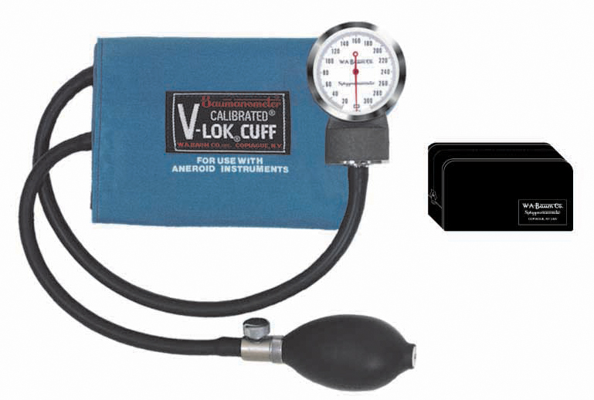

**Baum Pocket Aneroid**

Description

* 300 mmHg clinical sphygmomanometer for portable use.
* Meets the American National Standard ANSI/AAMI SP-10 for accuracy and performance.
* Available with Latex or Non-Latex components.
* Diecast zinc manometer housing.
* Precision low friction movement with twin pre-seasoned phosphor-bronze diaphragm capsules.
* Unique high contrast scale and red pointer for increased visibility and reduced parallax error.
* Calibrated® V-Lok® inflation System

Finish:

* Warm Gray textured baked enamel

Packaged Dimensions:

* 81⁄2” L x 47⁄8” W x 21⁄2” H

Packaged Weight:

* 1.05 lbs.

Standard Cuff Color:

* Medium Blue

Cuff Size:

* Adult

Inflation System:

* Calibrated® V-Lok®.

Holder:

* Zippered Case