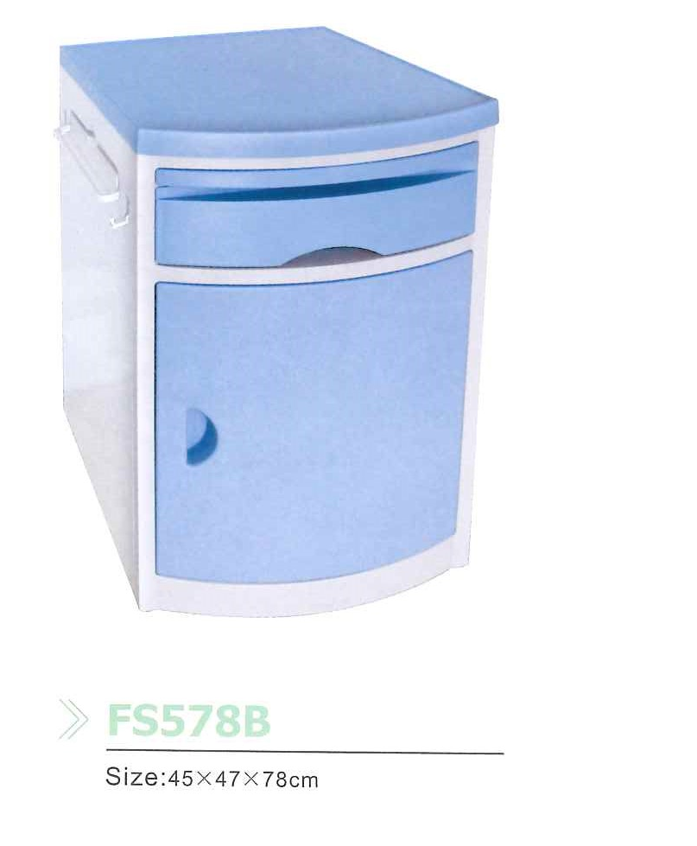

FS 578B – Bedside Table

Dimension: 47 x 46 x 78

· ABS PLASTIC

· Extra pull-out table

· Drawer

· Spacious cabinet with shelf and door.

· Retractable towel rack on sides.

· Mounted on wheels, blue in color